**Finding neighborhoods in Toronto which can be suitable for opening Italian Restaurants.**

RUPA BHOLANATH LAHIRI

July 3, 2020

### Introduction

A friend wants to open an Italian Restaurant in Toronto.

I need to explore the kind of businesses already existing in the neigborhoods and which could be an ideal neighborhood.

It maybe safer to go for a neighborhood to which already has a similar existing business so that it is not entirely risky to open a new business there.

### Data

First the neighborhoods in Toronto are scraped from Wikipedia <https://en.wikipedia.org/wiki/List_of_postal_codes_of_Canada:_M>.

Next the latitude and longitude data are part of the data from the Data Science Capstone Course.

The Venues and Venue Categories are obtained using Foursquare.

For creating features to be used to help in the analysis, the count of each category of Venue is calculated for each neighborhood.

Next these values are normalized.

The top ten categories in each neighborhood are kept for further analysis.

### Exploratory Data Analysis

There is a wide variation in the total number of Venues in each neighborhood.

Here is a distribution of the values in the form of a histogram and a box plot of the values.

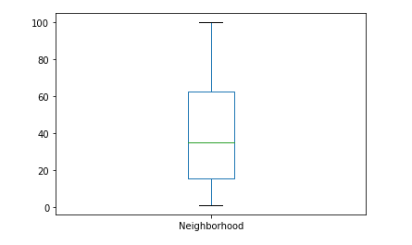

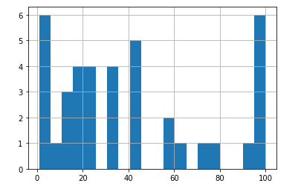

Hence, we need to normalize the values and keep the top top ten Venue Categories in each neighborhood.

Clustering like neighborhoods

It would be preferable to open a business in an area with the presence of other helpful business.

So we cluster the data using KMeans.

Here is a cluster of neighborhoods with the most frequent Venue Category.

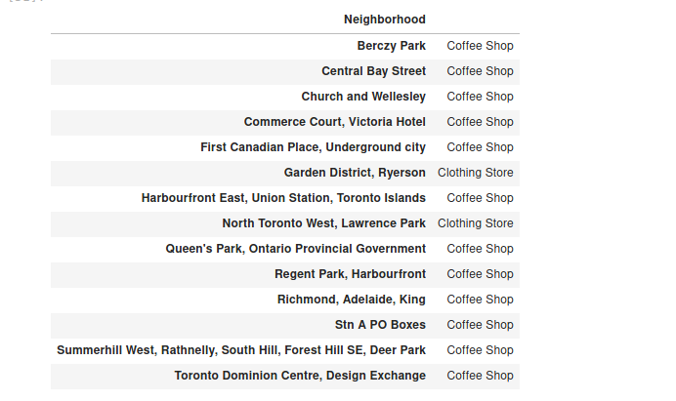

Here are the neighborhoods with the presence of Italian Restaurants and the corresponding normalized count of the Venue Category – Italian Restaurant.

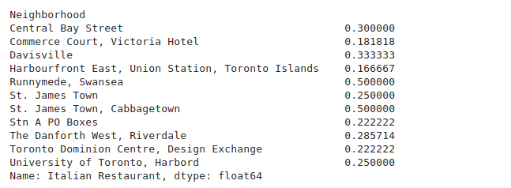

Here are the clusters to which these neighborhoods belong to.

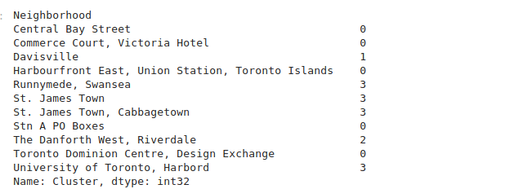

Here is a heatmap of the neighborhoods with Italian Restaurants.

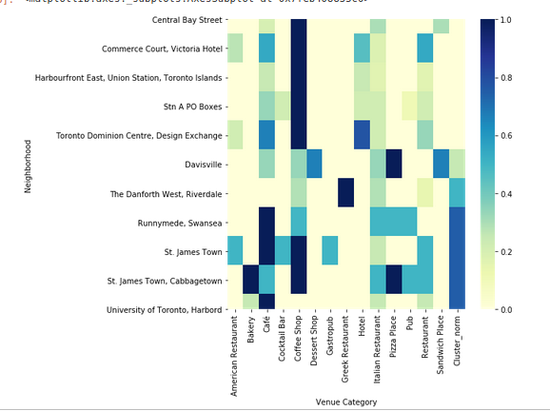

We can choose a neighborhood in a cluster with say more hotels or pizza place if we feel that the presence of these venues might boost the help the new venue.